ASSIGNMENT-10.4

NAME: NITHIN

H.NO:2403A52355

TASK-1:
Identify and fix syntax, indentation, and variable errors in the given script.

ERROR CODE :
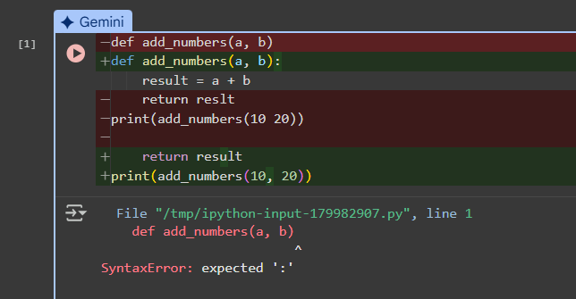

IMPROVISED CODE:
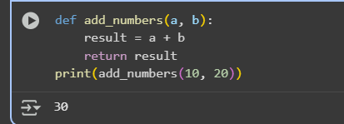
the original code had two errors:
- SyntaxError: expected ':': This error occurred because there was no colon at the end of the def add_numbers(a, b) line. In Python, function definitions must end with a colon.
- NameError: name 'reslt' is not defined: This error occurred because the variable result was misspelled as reslt in the return statement. Python is case-sensitive, so reslt was not recognized as the same variable as result.

EXPLANATION:
Defines a simple Python function called add_numbers that takes two arguments, a and b. It adds these two numbers together and stores the result in a variable called result. Finally, it returns the value of result. The line print(add_numbers(10, 20)) calls this function with the arguments 10 and 20, and then prints the returned value (which is 30) to the console.

TASK-2:
Optimize inefficient logic while keeping the result correct.

ERROR CODE:
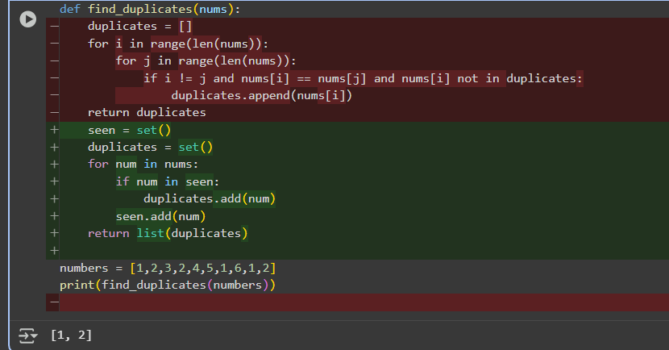

IMPROVISED CODE:
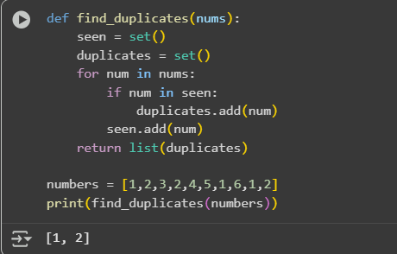

EXPLANATION:
- def add_numbers(a, b): defines the function that takes two arguments, a and b.
- result = a + b adds the two arguments and stores the sum in a variable called result.
- return result sends the value of result back when the function is called.
- print(add_numbers(10, 20)) calls the function with 10 and 20 as inputs and prints the returned value (which is 30).
Cell SnofwLeXL-mJ:
This cell contains a function called find_duplicates that finds duplicate numbers in a list using sets, and then demonstrates how to use it.
- def find_duplicates(nums): defines the function that takes one argument, a list called nums.
- seen = set() creates an empty set called seen. This set will store the numbers we've encountered so far.
- duplicates = set() creates an empty set called duplicates. This set will store the unique duplicate numbers found.
- for num in nums: starts a loop that iterates through each number in the input list nums.
- if num in seen: checks if the current number num is already in the seen set. If it is, it means we've seen this number before, so it's a duplicate.
- duplicates.add(num) adds the duplicate number to the duplicates set. Using a set here automatically handles adding each unique duplicate only once.
- seen.add(num) adds the current number num to the seen set, regardless of whether it was a duplicate or not.
- return list(duplicates) converts the duplicates set into a list and returns it.
- numbers = [1,2,3,2,4,5,1,6,1,2] creates a sample list of numbers.
- print(find_duplicates(numbers)) calls the find_duplicates function with the numbers list and prints the returned list of unique duplicates (which is [1, 2]).

TASK:3
Refactor messy code into clean, PEP 8–compliant, well-structured code.

CODE:
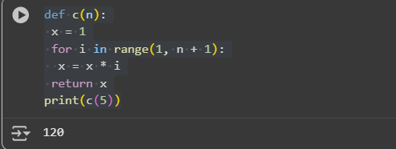

IMPROVISED CODE:
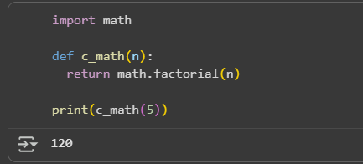

EXPLANATION:
These two cells contain the same code, which is a function c(n) that calculates the factorial of a number n iteratively.
- x = 1 initializes a variable x to store the factorial value.
- The for loop iterates from 1 up to n.
- x = x * i multiplies x by the current loop variable i in each iteration, effectively calculating the product 1 * 2 * 3 * ... * n.
- return x returns the calculated factorial.
- print(c(5)) calls the function with n=5 and prints the result (which is 120, the factorial of 5).
Cell ae357d81: This cell provides an alternative way to calculate the factorial using Python's built-in math module.
- import math imports the math module.
- def c_math(n): defines a function c_math that takes a number n.
- return math.factorial(n) uses the factorial() function from the math module to directly calculate and return the factorial of n.
- print(c_math(5)) calls this function with n=5 and prints the result (120).

TASK:4
Add security practices and exception handling to the code.

CODE:
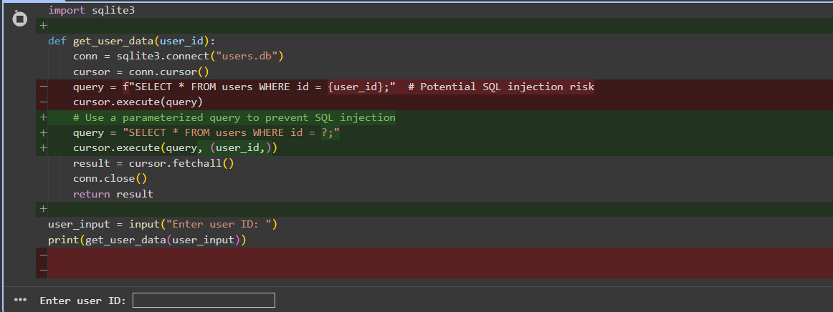

IMPROVISED CODE:
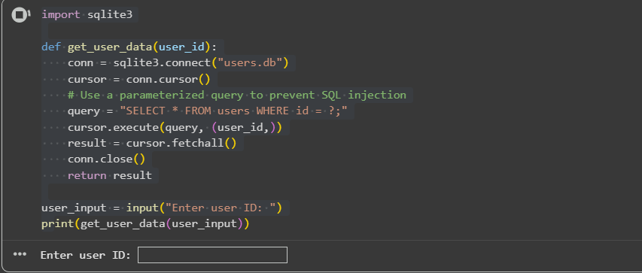

EXPLANATION:
This code defines a function get_user_data that retrieves data for a specific user from an SQLite database.
- import sqlite3: This line imports the necessary library for working with SQLite databases in Python.
- def get_user_data(user_id):: This defines the function get_user_data that takes user_id as an argument.
- conn = sqlite3.connect("users.db"): This line establishes a connection to an SQLite database file named "users.db". If the file doesn't exist, it will be created.
- cursor = conn.cursor(): This creates a cursor object, which is used to execute SQL commands.
- query = "SELECT * FROM users WHERE id = ?;": This defines the SQL query. It selects all columns (*) from the table named users where the id column matches a specific value. The ? is a placeholder for the user_id value.
- cursor.execute(query, (user_id,)): This is the crucial part for preventing SQL injection. Instead of directly embedding the user_id into the query string, we pass the query string with a placeholder (?) and the user_id as a tuple (user_id,) as the second argument to execute(). The sqlite3 library then handles substituting the user_id into the query safely.
- result = cursor.fetchall(): This fetches all the rows that match the query result and stores them in the result variable as a list of tuples.
- conn.close(): This closes the database connection. It's important to close the connection when you're finished with it.
- user_input = input("Enter user ID: "): This line prompts the user to enter a user ID.
- print(get_user_data(user_input)): This calls the get_user_data function with the user's input and prints the retrieved user data.

TASK:5
Generate a review report for this messy code.

CODE:
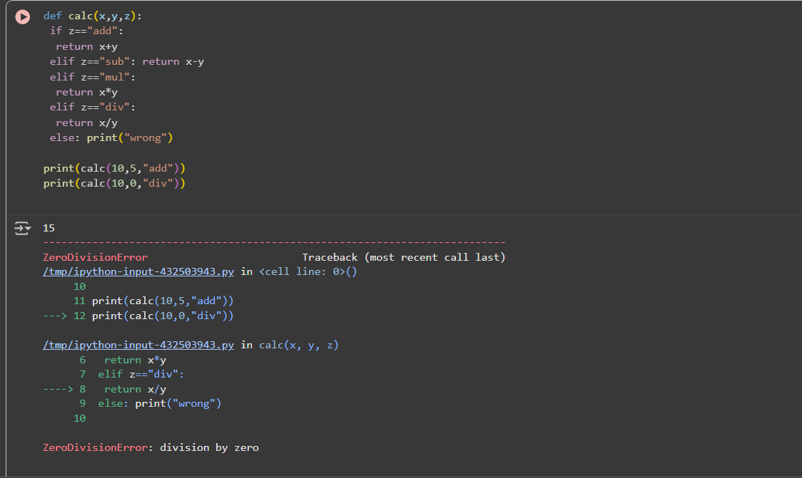

IMPROVISED CODE:
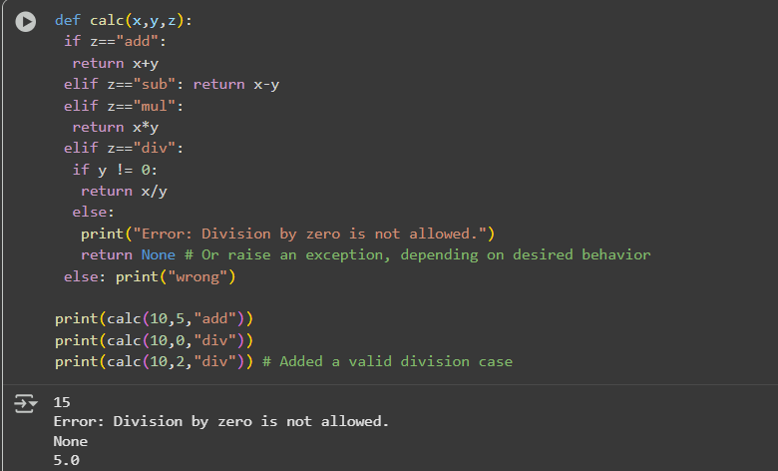

EXPLANATION:
Cell 4Nu65qpKTNTv:
This cell deals with interacting with an SQLite database.
- import sqlite3: Imports the necessary library.
- def get_user_data(user_id):: Defines a function to retrieve user data based on their ID.
- conn = sqlite3.connect("users.db"): Connects to the database file "users.db".
- cursor = conn.cursor(): Creates a cursor object to execute SQL commands.
- query = "SELECT * FROM users WHERE id = ?;": Defines the SQL query to select all columns from the users table where the id matches the placeholder ?.
- cursor.execute(query, (user_id,)): Executes the query using a parameterized approach, passing the user_id as a value to the placeholder. This is important for security to prevent SQL injection.
- result = cursor.fetchall(): Fetches all the results of the query.
- conn.close(): Closes the database connection.
- user_input = input("Enter user ID: "): Prompts the user to enter an ID.
- print(get_user_data(user_input)): Calls the function with the user's input and prints the result.
Cell p0TTmBDuU-Vt:
This cell contains a function calc that performs basic arithmetic operations based on a given operator.
- def calc(x, y, z):: Defines the function calc that takes two numbers (x, y) and an operator string (z).
- if z == "add": return x + y: If the operator is "add", it returns the sum of x and y.
- elif z == "sub": return x - y: If the operator is "sub", it returns the difference.
- elif z == "mul": return x * y: If the operator is "mul", it returns the product.
- elif z == "div":: If the operator is "div", it checks for division by zero.
  - if y != 0: return x / y: If y is not zero, it returns the result of the division.
  - else: print("Error: Division by zero is not allowed."); return None: If y is zero, it prints an error message and returns None.
- else: print("wrong"): If the operator is not one of the recognized operations, it prints "wrong".
- The print statements at the end demonstrate how to call the calc function with different arguments.

